Name: M. Pradeepa Reg. No: 20Y012

Exercise 2:

**INHERITANCE**

**AIM:**

To develop a java program to implement inheritance.

**PSEUDOCODE:**

Class Student

Integer roll_number Method getValue(integer n) Assign roll_number to n Method putValue( )

Print roll_number End Student class

Class Test inherit the property of Student class floating value part1, part2

Method getValue(float m1,float m2)//Method overriding Assign part1 to m1 and part2 to m2

Method putMarks() Print part1 and part2

End Test class

Interface Sports

Floating value sportwt Assign 66.0F to sportwt Method putwt()

End interface

Class Result inherit from Test class and implement from Sports class Floating value total

Method putwt() Print sportwt Method display()

Total=part1+part2+sportwt

putValue() putMarks() putwt() print Total

End Result class

Class Output Main method

Create result’s object student1 Student1.getValue(001) Student1.getValue(80.5F, 77.0F) Student1.display()

End main End Output class

**CODE:**

import java.io.*; class Student

{

int roll_number; void getValue(int n)

{

roll_number=n;

}

void putValue( )

{

System.out.println("Roll No.:"+roll_number);

}

}

class Test extends Student

{

float part1,part2;

void getValue(float m1, float m2)

{

part1 = m1; part2 = m2;

}

void putMarks( )

{

System.out.println("MARKS OBTAINED"); System.out.println("Mark 1="+part1);

System.out.println("Mark 2="+part2);

}

}

interface Sports

{

float swt=6.0F; void putwt();

}

class Results extends Test implements Sports

{

float total;

public void putwt( )

{

System.out.println("Sportswt="+swt);

}

void display( )

{

total=part1+part2+swt; putValue( ); putMarks( );

putwt( );

System.out.println("Total Score="+total);

}

}

class Output

{

public static void main(String args[ ])

{

Results student1=new Results(); student1.getValue(1234); student1.getValue(27.5F,33.0F); student1.display();

}

}

**OUTPUT:**

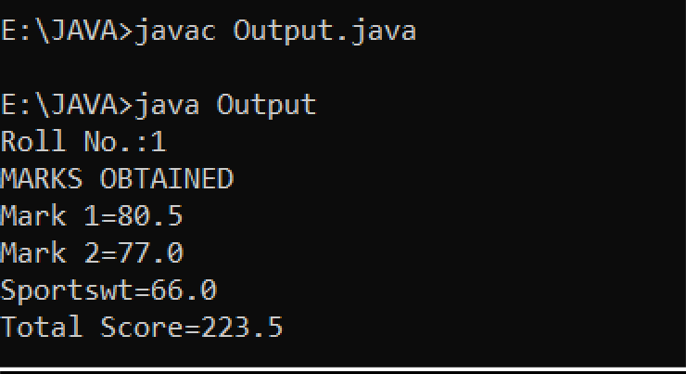

**RESULT:**

Thus, The program has been executed successfully.